**POSSUM KINGDOM**

**OBSTACLE**

**COURSE**

**SLIDE**

**BOUNCE**

**GAMES**

**DOOR PRIZES**

**CANDY**

**FOOD**

**CAKE WALKS**

**TRUNK OR TREATS**

**COMMUNITY FESTIVAL**

**CEDAR SHOALS**



**CAR AND BIKE SHOW**

**BAPTIST CHURCH**

**1045 COOLEY BRIDGE ROAD**

**BELTON, SC 29627**

**SUNDAY, OCTOBER 21**

**FESTIVAL 4 PM – 7 PM**

**CONCERT WITH BASIC LIFE 7 PM** 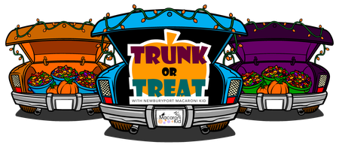

“The United States Constitution requires schools to respect the right of all external organizations to distribute flyers to students at school if the school permits any such organization to distribute flyers. Accordingly, the school cannot discriminate among groups wishing to distribute flyers at school and does not endorse the content of any flyer distributed at school. The school encourages parents to assist their children in making choices appropriate for them.